Chapter 16, Problem 89.

Develop the state equations for the circuit shown in Fig. 16.103.

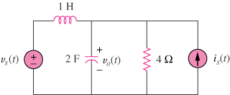

Figure 16.103
For Prob. 16.89.

